**Circuit Design – Fixed Challenge 2019**

Table of Contents

Circuit design – Main PCB – Fixed Challenge 2019 4

Overview of the Circuit 4

Filtering 5

High pass 5

Low pass 6

Notch 6

Common mode chokes 7

Right leg driver 8

RF filters 8

Amplification 9

Operational amplifier 9

Instrumentation Amplifier 9

Circuit Amplification 10

Simulation 11

High pass filter 11

Low pass filter 12

Notch 13

Complete circuit for 1 channel 14

Other Components 15

Power supply 15

ADC 15

DC-to-DC converters 15

Protections 16

Schematic, layout and routing 17

Testing 19

Board cost 20

Circuit design – Secondary PCB – Fixed Challenge 2019 21

Circuit Overview 21

Filtering 22

High pass filter 22

Low pass filter 22

Notch 23

Amplification 24

Instrumentation amplifier 24

Circuit amplification 24

Simulation 25

High Pass Filter 25

Low Pass Filter 26

Notch 27

Complete channel 28

Other components 29

ADC 29

Protection 30

Schematic, Layout and Routing 31

Testing 33

Board Cost 34

Annexes 35

Table 1 : List of components of the main PCB 35

Table 2 : List of components for secondary PCB 36

Reference 37

# Circuit design – Main PCB – Fixed Challenge 2019

## Overview of the Circuit

PolyCortex is a neurotechnology student organization that partakes in the NeuroTechX Fixed and Open Challenge competitions. The electronic team tasked with designing the circuit and PCB for the acquisition of EEG signal (Fixed Challenge) works alongside the informatic team in charge of programming an interface to visualize the signal.

The circuit PolyCortex has design for this year’s fixed challenge is detailed in this document. It is composed of 4 separate channels that can be wired to electrodes. Each channel includes filtering components (common mode chokes, RF filters), instrumentation amplifiers, various filters (high pass, low pass and notch) and a final amplification stage. Once the signal is treated and amplified, it is directed to the ADC which converts the signal from analog to digital in order to be forwarded to the interface for visualization. The circuit is powered by a 9V battery. However, the ADC is powered by ±2.5V obtained with DC-to-DC converters included in the circuit. To insure the grounding standard of the board, a right leg driver (RLD) circuit configuration has been added to the board. Lastly, the subject wearing the electrodes is protected by a transient voltage suppressor (TVS).

The conception of the circuit was simulated with LTspice and implemented in the DipTrace software, which allows the creation of a schematic and layout of the PCB. It was printed by Labo Circuits Inc. and the components ordered from Digi-Key Electronics were welded by PolyCortex’s electronic team.

## Filtering

Due to their weak amplitudes, EEG signals are very susceptible to electromagnetic and common mode contamination. Additionally, EEG signals collected with electrodes may contain EMG information from the subject’s muscular activity and ECG signals from the polarizing cycles of heart cells. Is it thus important to filter the signal to isolate the frequency bands of interests for EEG analysis. The electroencephalogram is composed of 4 district waves ranging between 0.5 and 30Hz; the beta wave (13-30Hz), the alpha waves (8-13Hz), the theta waves (4-8Hz) and the delta waves (0.5-4Hz). PolyCortex therefore decided to filter outside of a bandwidth ranging from 0.3 to 35Hz to preserve all relevant EEG information.

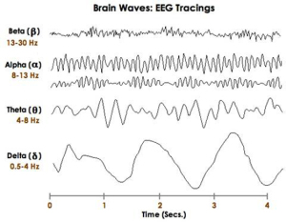

*Figure 1 : Frequencies of EEG waves*

### High pass

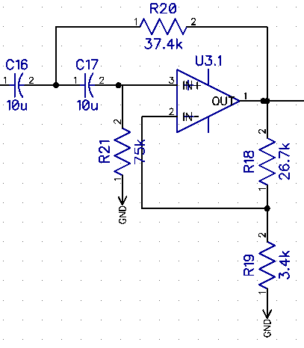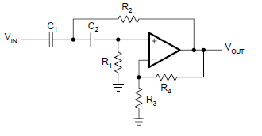The first filtering stage is a high pass Butterworth filter of the second order. The cutoff frequency f of such a filter is determined by the value of R2 and the value of C1 following the equation with R1=2* R2 and C1= C2. PolyCortex has chosen R1 = 75kΩ, R2 =37.4kΩ and C1 = C2 = 10µF, thus providing a cutoff frequency of 0.3Hz. The remaining resistor provide a gain to the filter, as explained in the Circuit Amplification section.

*Figure 2 : High pass filter configuration (left : DipTrace schematic, right: theorical configuration)*

### Low pass

To insure the cutting off of EMG signals and other noise, the Butterworth low pass filter has a cutoff frequency of 35Hz. The cutoff frequency of this filter is given by the following equation $f= \frac{1}{2*π}*\sqrt{\frac{1}{R_{1}R_{2}C_{1}C_{2}}}$ referring to the right-side image of figure 5. In PolyCortex’s schematics (left-side of figure 5), these values have been set to R1 = 3.4Ωk, R2=60.4Ωk, C1= 0.1µF and C2= 1µF. Therefore, the cutoff frequency is 35Hz.

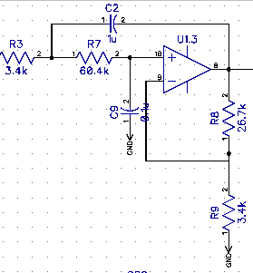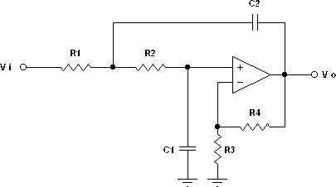

*Figure 3 : Low pass filter configuration (left : DipTrace schematic, right: theorical configuration)*

### Notch

When working near electrical power-lines, the electronic circuits will be affected by the mains hum, or electric hum, which is a noise associated with the alternating current of the power-line. In PolyCortex’s case, the fundamental frequency of the mains hum is 60Hz coming from Hydro-Quebec and has a maximum intensity of 30dB. It was considered wise to add a notch filter to the circuit to target this specific intense noise. For this specific configuration, the cutoff frequency is given by the equation $f= \frac{1}{2*π}*\sqrt{\frac{1}{R_{1}R_{2}C_{1}C_{2}}}$ with $R_{3}=R_{1}+R_{2}$ and $R_{4}= R_{5}={2* R}_{3}$ (referring to the right-side of figure 6). To obtain a cutoff frequency centered around 60Hz with a gain of at least -30dB to eliminate the mains hum, PolyCortex chose values of R1 = R2 = 5Ωk, R3 = 10Ωk, R4 = R5 = 20Ωk, C1 = 94nF and C2 = 3 µF. These values produce a gain of about -36dB when simulated in LTspice (see simulation section).

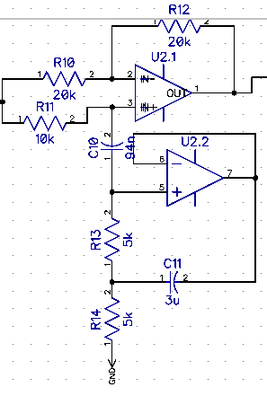

*Figure 4 : DipTrace schematic for the notch filter (cut-off frequency of 60Hz)*

### Common mode chokes

The circuit includes common mode chokes to eliminate a maximum of electromagnetic and radio frequency interferences from the power supply lines. The common-mode current creates a magnetic field when passing through the coil that opposes any increase of its intensity, thus blocking the common-mode current and passing differential current. PolyCortex chose CM4732V301R-10 by LAIRD, which works at a maximum current of 8,000mA and 30V.

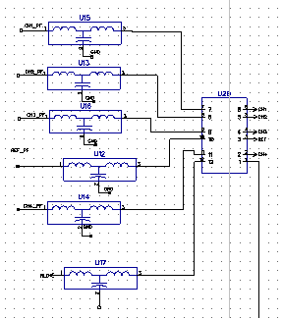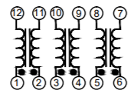

*Figure 5 : DipTrace schematic of common mode chokes (left) and equivalent circuit (right)*

### Right leg driver

According to Texas Instruments, the common-mode rejection (CRM) is one of the most important parameters in ECG and EEG systems. Therefore, a right leg driver (RLD) circuit was added to further decrease the common-mode interference. The RLD circuit sets the user’s common-mode voltage to increase the effective common-mode rejection ratio of the circuit and low-passes the common-mode voltage measured by the differential amplification stage. This method provides a grounding standard by preventing the lost of voltage due to the difference in impedance between the ground electrode on the subject and the circuit itself.

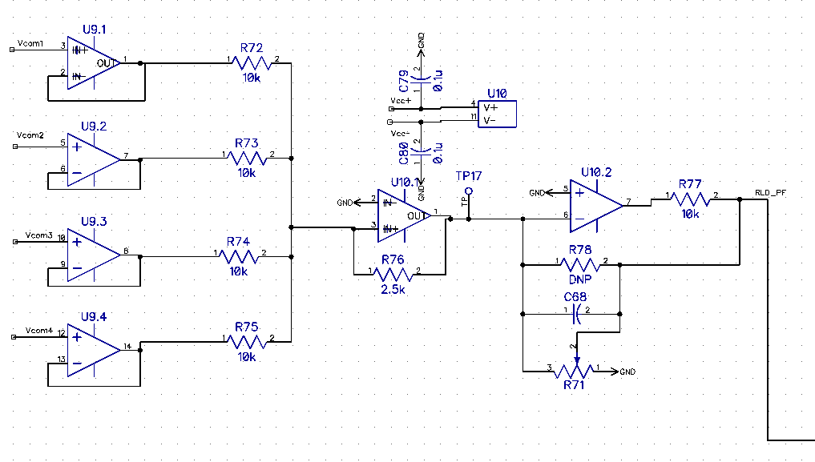

*Figure 6 : Schematic for right leg driver*

### RF filters

Radio frequency (RF) filters were added to the circuit to remove high frequency (MHz-GHz) signals originating from broadcast and wireless communication. The filtering of these frequencies is important considering they could affect the envelop of the output signal. PolyCortex uses Bourns Inc.’s EMI103T-RC filter for their good noise filtering properties, which also attenuate the mains hum with a factor of about -50dB.

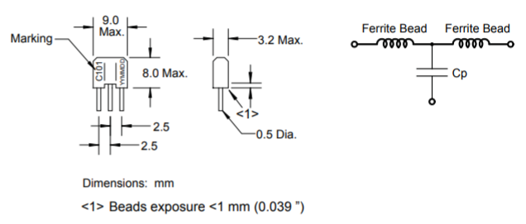

*Figure 7 : Configuration of RF filter (left : DipTrace schematic, right : functional diagram)*

## Amplification

Electrical signals coming from the human body have weak amplitudes typically ranging from 1mV to 100mV. For the electroencephalogram (EEG), the voltage that can be measured at the surface of the brain is about 1-2mV whereas it decreases to microvolts (μV) when measured on the scalp with electrodes.[1] Thus acquiring and visualizing EEG signals requires amplification of ~ 5 000. Such a gain allows the manipulation of the signals without saturating the operational amplifiers present in the circuit.

### Operational amplifier

The op-amps used in the circuits are Texas Instruments’ trusted LM324. They were chosen for their built-in 4 operational amplifiers, their supply range of 3.0 to 32V and their typical common-mode rejection of -120dB.

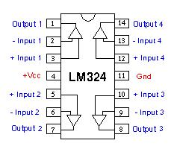

*Figure 8 : functional diagram of LM324 amp-op*

### Instrumentation Amplifier

The circuit to acquire EEG signals contain an operational amplifier placed directly after the electrodes to provide the signal with an initial gain before being filtered. The op amp used is Analog Devices’ AD8422, which is a high performance, low power, rail-to-rail precision amplifier. For the AD8422, the gain is determined by placing a single resistance RG across pin 2 and 3. PolyCortex decides the value of this resistance would be two times 250Ω, therefore inducing a gain of 40.6 (Gain = 1 + 19.8kΩ/RG). Furthermore, the datasheet suggests placing bypass capacitors (C3, C4, C5 and C6) as close as possible to each supply pins to regulate the supply tension.

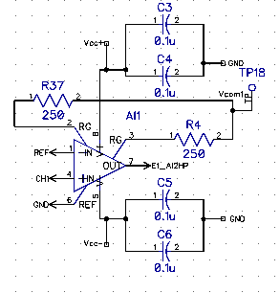 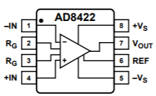

*Figure 9 : DipTrace Schematic and connection diagram of the in-op* *AD8422*

### Circuit Amplification

To obtain the expected gain of ~5 000, the different filtering layers can also be used to introduce a gain. The filters used in this EEG circuit are second order Butterworth active filters where two resistors (Rf and Ri) , R18 and R19 on figure 2, can be connected to the output signal without affecting the cutoff frequency. Consequently, the gain of the high pass and low pass filter is proportional to the ratio of these two resistors (Gain = 1 + Rf/Ri). During the design process, PolyCortex chose to introduce a gain of 8.9 in both filtering levels.



*Figure 10 : High pass filter with a gain (G = 1 + R18/R19) of 8.9*

After the signal has made its way through the amp-op and the filtering levels, it is amplified a final time with a non-inverting operational amplifier. For this configuration, the gain is once more proportional to the ratio of the chosen resistors (Gain = 1 + Rf/Ri) R30 and R31 on figure 3.

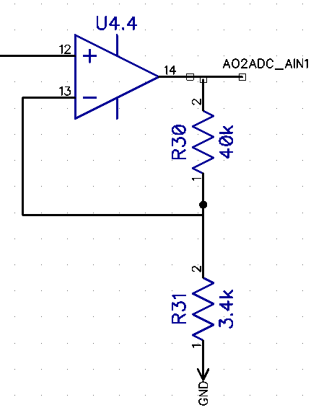

*Figure 11 : Final amplification level with a gain of 12.8 (G = 1 + R30/R31)*

The total gain produced by the cascading of the amp-op, the high pass and low pass filter and the non-inverter is thereby the multiplication of each individual gain, producing a final gain of ~41100.

## Simulation

To insure the circuit behaves like it should, PolyCortex simulated every filtering stages with LTspice and tested the final amplification as well as the filtering capacities. In order to test the filters, a AC Analysis with 100 steps per decade, a start frequency of 1Hz and a stop frequency of 200Hz. This kind of analysis allows the visualizing of the circuit’s frequency response between the start and stop frequency and displays the Bode plot.

### High pass filter

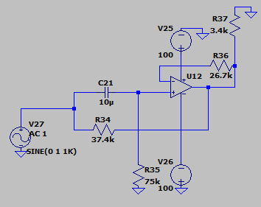

*Figure 12 : LTspice schematic of the high pass filter*

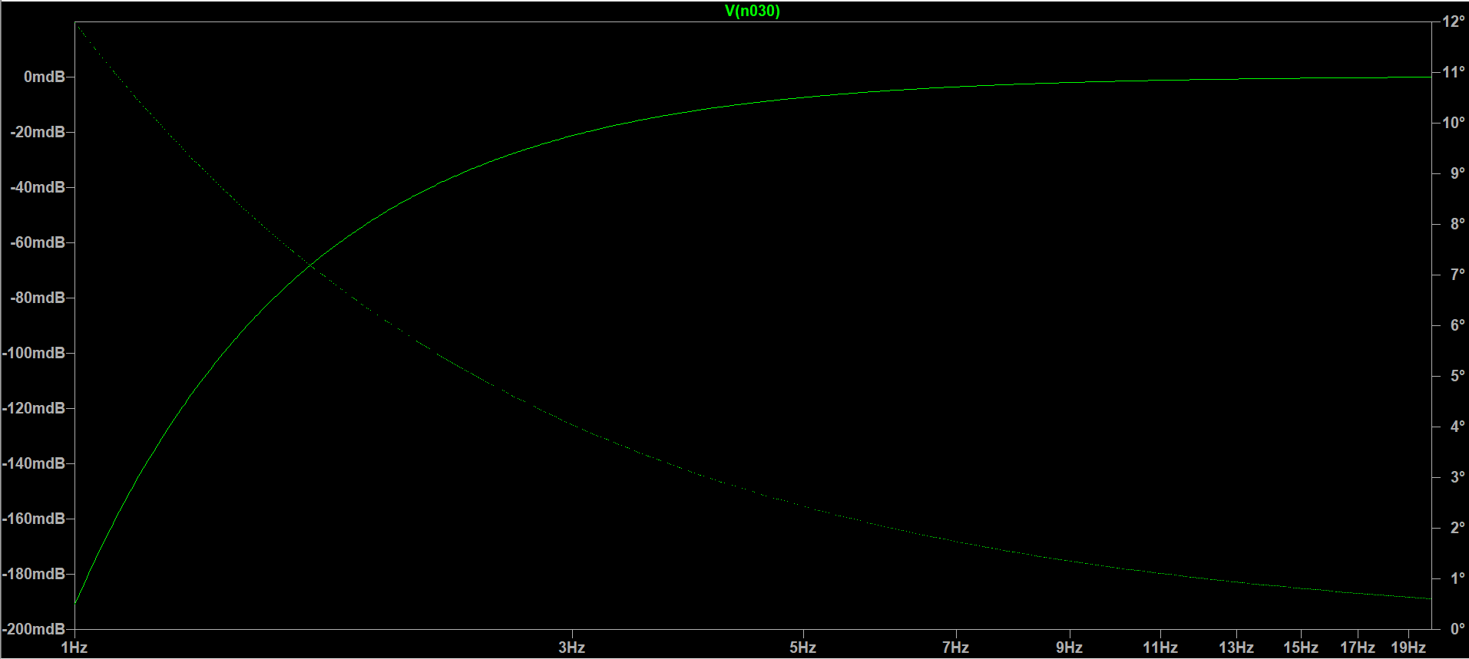

*Figure 13 : Bode plot of high pass filter with a cutoff frequency of 0.3Hz*

### Low pass filter

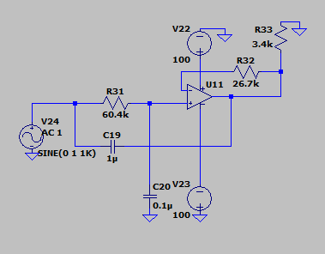

*Figure 14 : LTSpice schematic of low pass filter*

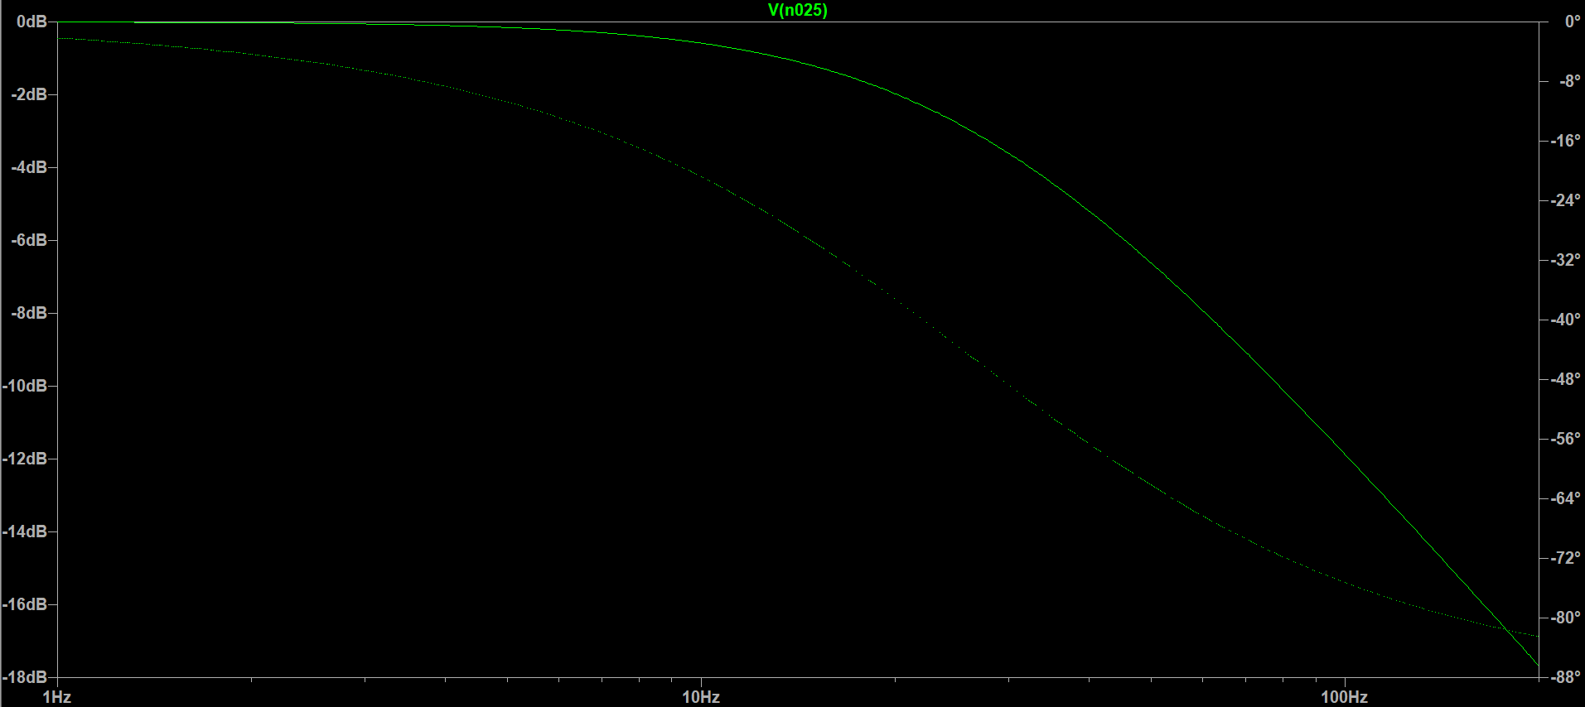

*Figure 15 : Bode plot of low pass filter with a cut off frequency of 35Hz*

### Notch

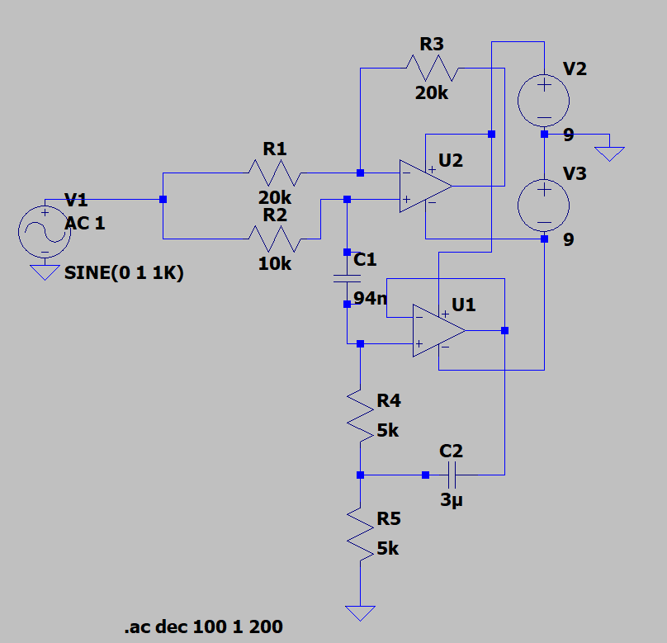

*Figure 16 : LTspice schematic of notch filter*

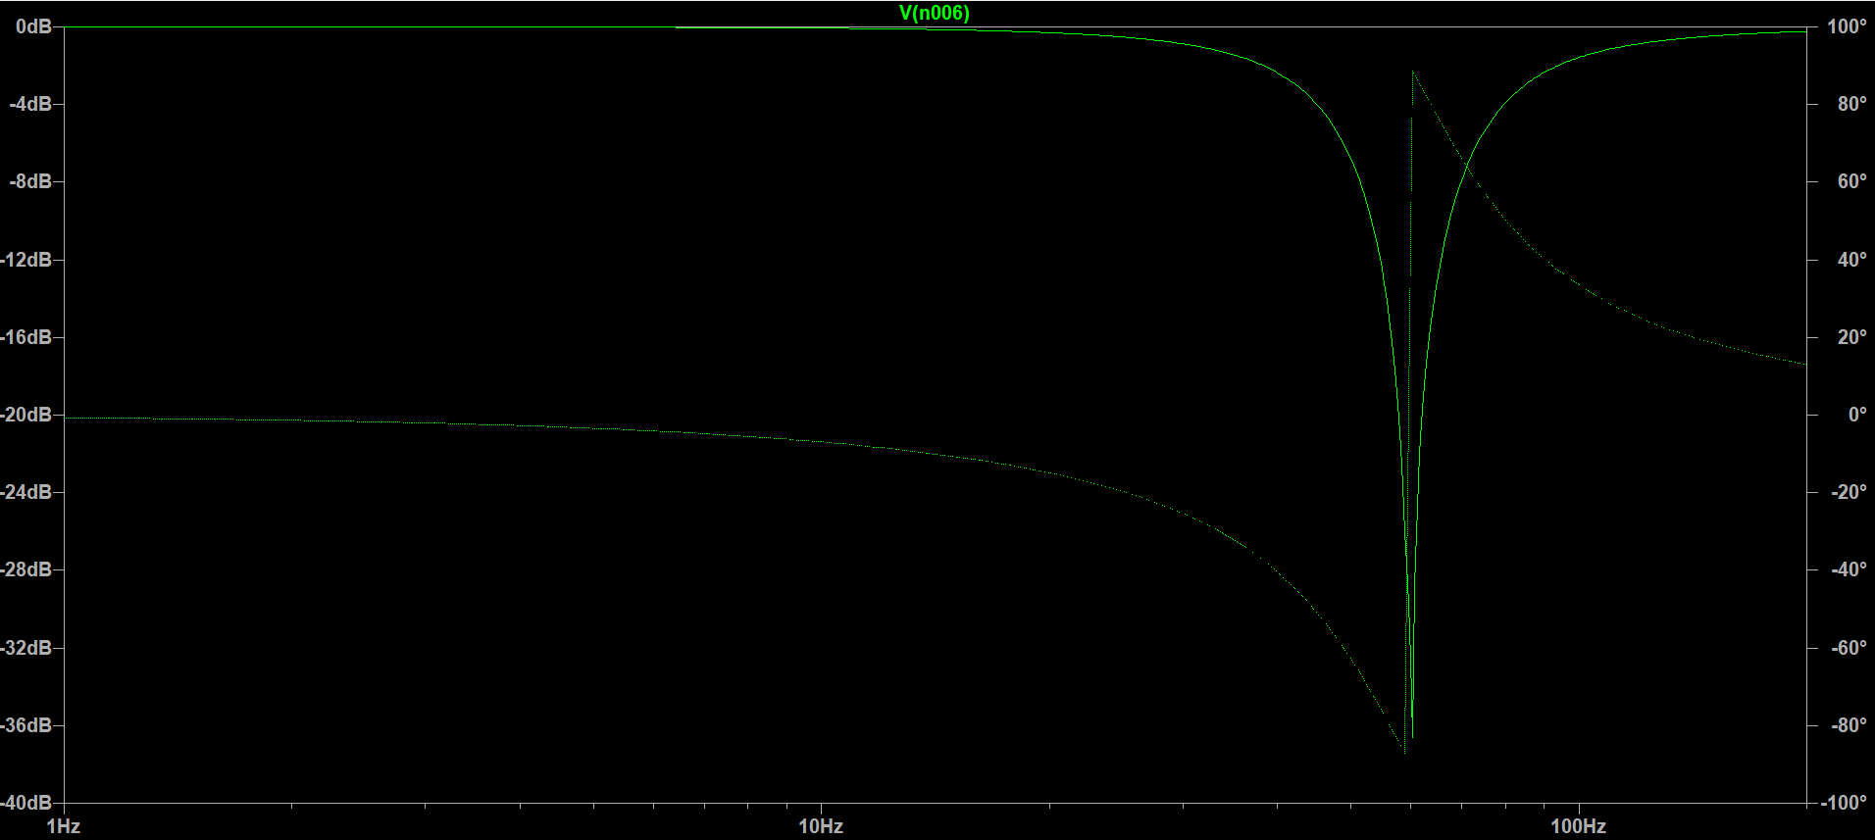

*Figure 17 : Bode plot of notch filter with a center frequency of 60Hz*

### Complete circuit for 1 channel

To test the complete circuit of a channel, the Transient analysis was used with a stop time of 0.7 seconds. Such an analysis allows the visualisation of the non linear transition response of the circuit in the temporal domain, much like an oscilloscope would. The input signal is a sin wave with an amplitude of 50µV and a frequency of 10Hz. As seen in figure 19, the output signal as an amplitude of ~2.05V, indicating a gain of ~41000.

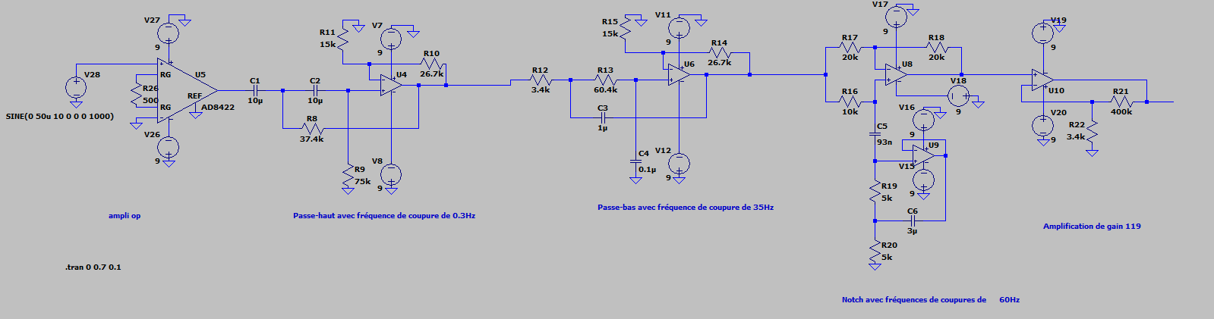

*Figure 18 : LTspice schematic of complete circuit of 1 channel*

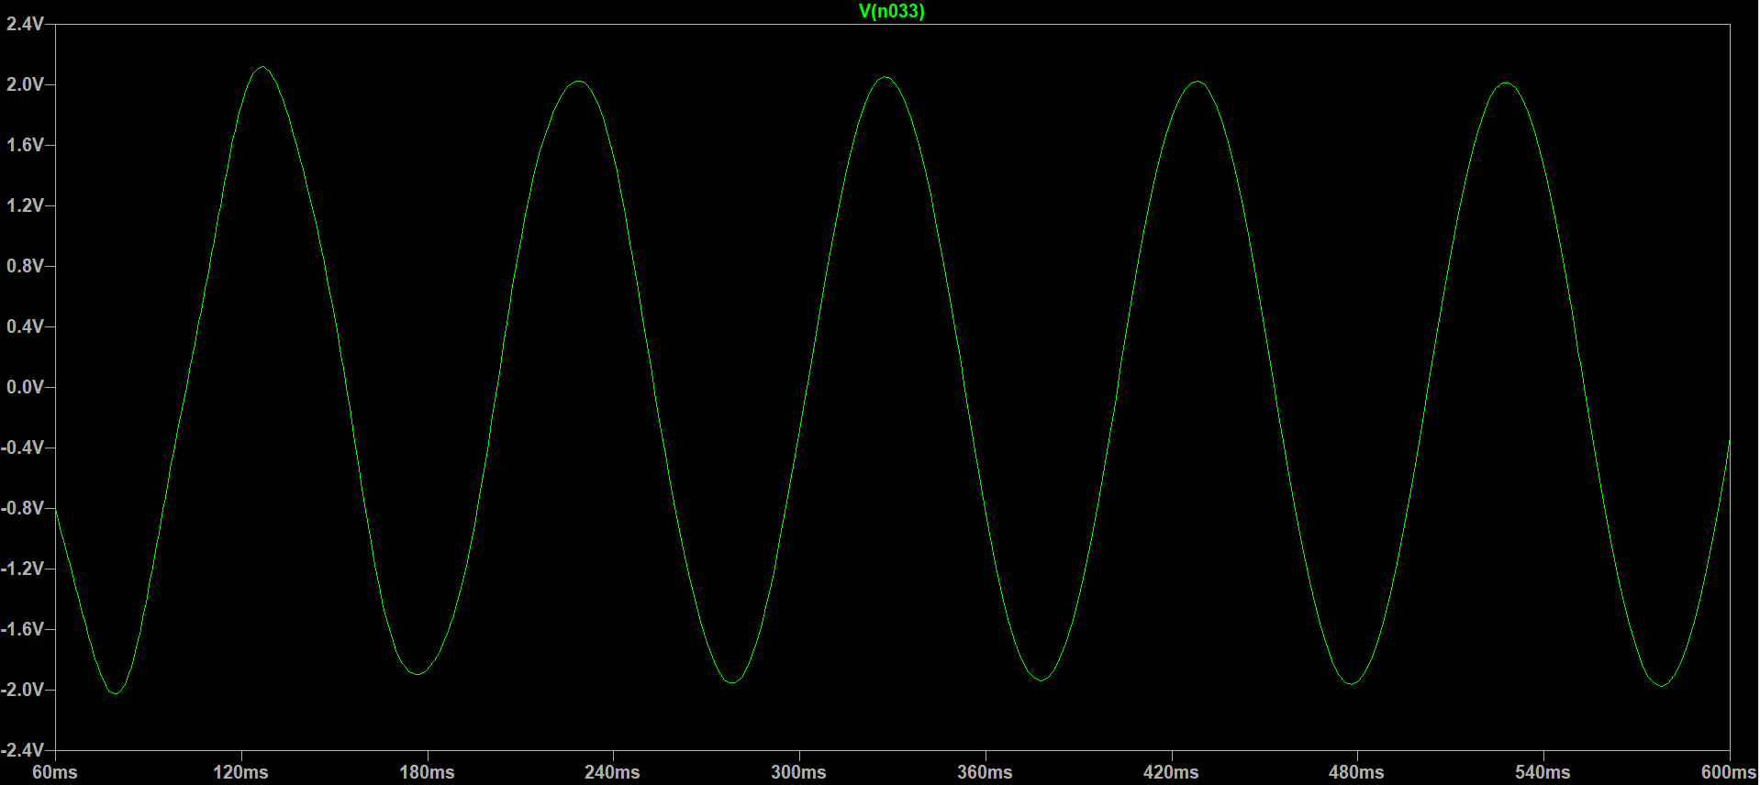

*Figure 19 : Output signal of complete circuit of 1 channel*

## Other Components

### Power supply

In previous version of the EEG acquisition circuit, the amp-ops were supplied with 5V and saturation was observed while gathering EEG data. Instead of decreasing the overall gain of the circuit, PolyCortex decided to increase the power supplying the circuit. The Vcc+ net of the circuit was thus set to 9V and the Vcc- to -9V since the board is powered with 9V batteries.

### ADC

The PCB created to acquire the EEG waves is made to be plugged into an interface to visualize the signals. To insure the communication between the circuit and the interface’s program, the voltage of the four channels must be converted from analog to digital. Texas Instruments’ 24-bit ADS122C04 was selected for its 4-channel input, its high sampling rate of 2kSPS. Furthermore, this ADC uses the Delta-sigma analog-to-digital converting method, which pushes the noise to higher frequency in order to increase its resolution. This ADC also helps eliminate common-mode noise by providing a typical CMRR of 110dB for a frequency of 60Hz (with DR=2kSPS).

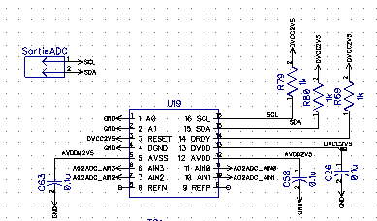 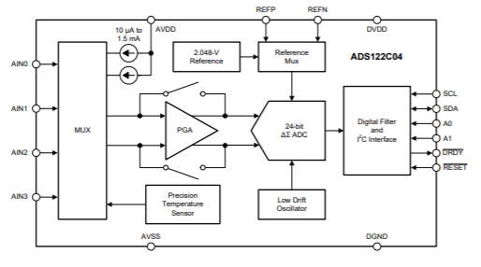

*Figure 20 : DipTrace schematic of the ADS122C04 ADC and functional diagram*

### DC-to-DC converters

The ADC require ±2.5V analog and digital supply to function. Therefore, a LT3483IS6 and a LMZ12002TZ DC-to-DC converter were added to the circuit in order to transform the 9V from the battery to ±2.5V while also regulating the voltage input of the ADC. The LT3483 is commonly used to produce analog negative voltage outputs, while the LMZ12002TZ is used to carry out analog and digital output. Both were chosen for their input range (2.5V to 16V for LT3483IS6 and 4.5V to 20V for LMZ12002TZ) which largely accommodate the 9V of the battery and their voltage output (-2.5V to -38V for LT3483IS6 and 0.8V to 6V for LMZ12002TZ) suitable to power the ADC.

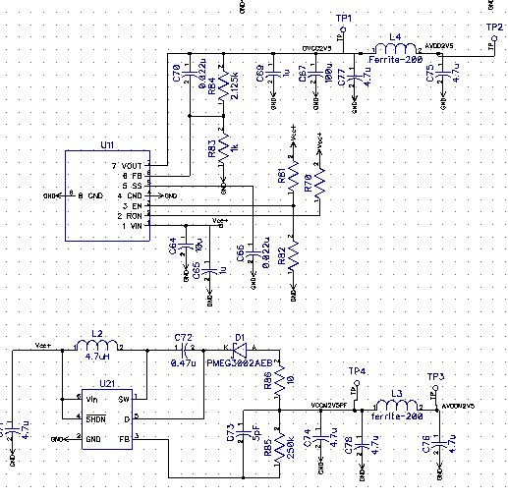

*Figure 21 : DipTrace schematic of DC-to-DC converter (top : LMZ12002TZ, bottom : LT3483IS6)*

### Protections

Since PolyCortex will be testing the board on a human being to acquire their EEG signals, it was considered wise to add a circuit protection component between the electrodes and the beginning of the circuit. Texas Instruments’ TPD4E1B06DCKR 4-channel bi-directional Transient Voltage Suppressor (TVS) diode array was chosen for its low leakage current (0.5nA) which insure the precision of analog measurements. It offers protection for currents exceeding 3.0A (8/20µS).

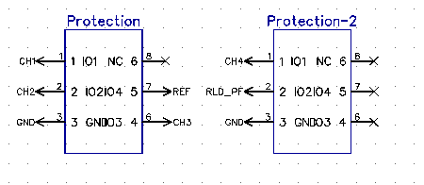 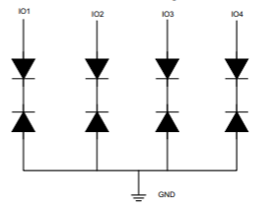

*Figure 22 : DipTrace schematic of protection circuit TPD4E1B06DCKR and functional diagram*

## Schematic, layout and routing

Before the PCB can be printed out, the circuit must be built on a schematic. Then, the schematic is converted to a PCB, where the components must be placed and routed to one another. These steps were executed with the DipTrace software, which offers a schematic capture editor, a PCB layout editor, a component editor and a pattern editor module. The component and pattern editor tools are used to incorporate custom component that might not be included in DipTrace libraries.

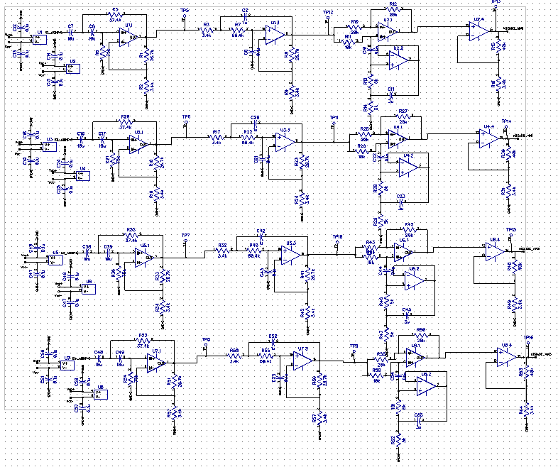

*Figure 23 : DipTrace schematic for 4-channel circuit*

The PCB PolyCortex created has 4 layers : the top one contains the pads on which the components are wielded and wires, the middle layers consists of the ground and power supply, and the bottom layer contains additional wiring. A copper plating was placed on top to surround the components and wires to further isolated them and reduce parasitic interference between the channels.

When doing the layout, PolyCortex took into consideration the size of the board, which could not exceed 15cm by 15cm, and the proximity of the components. The components were placed as close to each other as possible to minimize signal quality degradation. Furthermore, the analog and digital components were separated to avoid interference. While routing the circuit, the 90° angles were carefully avoided to prevent current concentration. Long parallel wire line were also avoided to stop parasitic impedance from containing the signals.

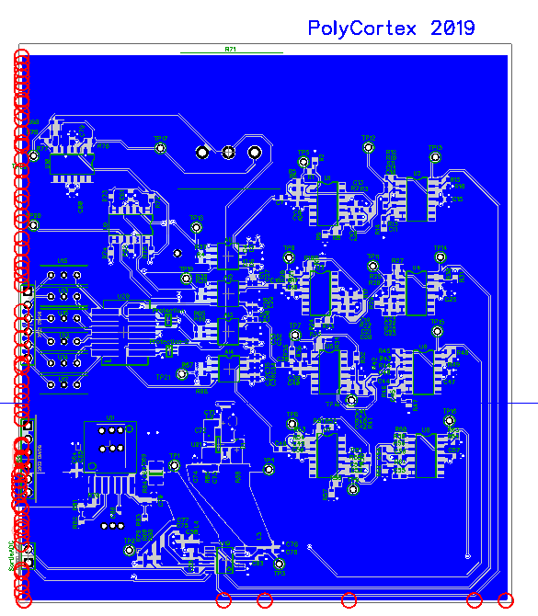

*Figure 24 : DipTrace layout of the finished PCB*

The completed PCB was exported in *gerber* files and sent to Labo Circuits Inc. for printing.

## Testing

Test the circuit by connecting a sinusoidal signal with a waveform generator at the minimal tension (i.e. 20 mV) and at a frequency of 20 Hz. Connect the positive terminal of the waveform generator to the electrode 1 (on the “Electrodes” header) and the negative terminal to the reference electrode (on the “Electrodes header). Connect with femalefemale wires the GND and the Vcc (on the “Supply” header) to the 9V battery. Connect the negative terminal of an oscilloscope to the GND and the positive terminal to the “E1” electrode (on the “SortieADC” header). A square signal at 20 Hz should appear. Because the lowest amplitude generated by the instrument is much higher than an EEG signal (20 mV >> 100 µV), the output signal is saturated which explains the square form.

## Board cost

A list of the 207 components of the circuit is annexed to this document. The total cost of the component, which were ordered on Digi-Key Electronics, is 157,06 CAN$. The PCB was printed by Labo Circuits Inc. for a fix cost of 225 CAN$ and 57,16$ per copy. The board cost can therefore be evaluated to 282,16 CAN$. The total cost of the board with the component is 439,21 CAN$.

# Circuit design – Secondary PCB – Fixed Challenge 2019

## Circuit Overview

The circuit presented previously is considerably more complex than the minimum required to acquire EEG waves. Therefore, PolyCortex chose to develop a secondary PCB to account for the potential mistakes in the main PCB and to still deliver a functional prototype. This secondary PCB contains the strict minimum to filter, amplify and convert the signals from analog to digital, while still insuring the safety of the subject on which the electrodes are connected. The circuit is separated between the analog and the digital portion, which are respectively powered by 9V batteries and by an Arduino microcontroller. The analog portion includes 4 channels composed of an instrumentation amplifiers, three stages of filtering and a final amplification stage. The digital portion includes the ADC component to insure the transfer of the data onto the interface and is powered with 3.3V from the Arduino. Furthermore, the board has two separate outputs for digital and analog data.

## Filtering

### High pass filter

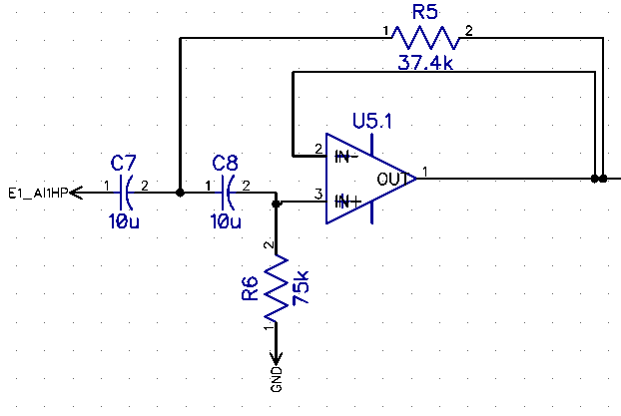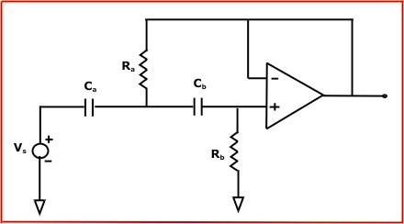During testing of the main card, the PolyCortex team noticed unexpected saturation behavior between the different filtering stage. It was thus decided to remove the resistor responsible for the gain of the filters (see figure 2), as they can modify the frequency response and can degrade the signal with a gain that’s too high. The high pass filter used for this circuit is the same Butterworth 2nd order configuration, but it doesn’t provide any amplification gain to the signal. The cutoff frequency *f* of such a filter is determined by the value of Ra and the value of Ca following the equation with Ra=2* Rb and Ca= Cb. PolyCortex has chosen Ra = 75kΩ, Rb =37.4kΩ and Ca = Cb = 10µF, thus providing a cutoff frequency of 0.3Hz.

*Figure 25 :* Secondary PCB h*igh pass filter configuration (left : DipTrace schematic, right: theorical configuration)*

### Low pass filter

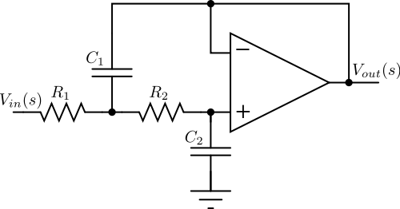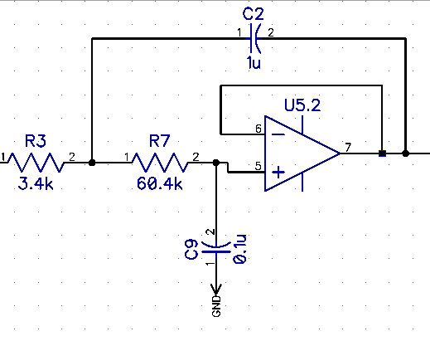 Similarly to the high pass filter, the resistors responsible for the gain of the lowpass filter were removed from the configuration. The cutoff frequency of this filter is given by the following equation referring to the right-side image of figure 26. In PolyCortex’s schematics (left-side of figure 5), these values have been set to R1 = 3.4Ωk, R2=60.4Ωk, C1= 0.1µF and C2= 1µF. Therefore, the cutoff frequency is 35Hz.

*Figure 26 : Secondary PCB low pass filter configuration (left : DipTrace schematic, right: theorical configuration)*

### Notch

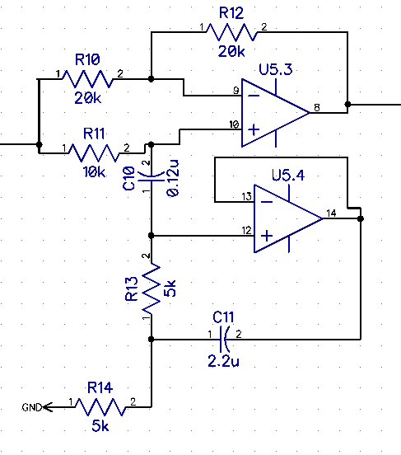The notch used for this circuit is the same as the one design for the main PCB (see figure 4), and therefore also has a narrow bandwidth cutting the 60Hz frequency. For this specific configuration, the cutoff frequency is given by the equation with and (referring to the right-side of figure 6). To obtain a cutoff frequency centered around 60Hz with a gain of at least -30dB to eliminate the mains hum, PolyCortex chose values of R1 = R2 = 5Ωk, R3 = 10Ωk, R4 = R5 = 20Ωk, C1 = 0.12µF and C2 = 2.2µF.

*Figure 27 : Secondary PCB notch filter configuration (left : DipTrace schematic, right: theorical configuration)*

## Amplification

Since the resistors providing a gain on each filtering stages were removed, the amplification provided by the instrumentation amplifier and the last amplification stage needed to be increased. The operational amplifiers used are still Texas Instruments’ LM324 (see Operational amplifier section of Main PCB and figure 8). Furthermore, the instrumentation amplifier used for this circuit is still the AD8422 (see figure 9).

### Instrumentation amplifier

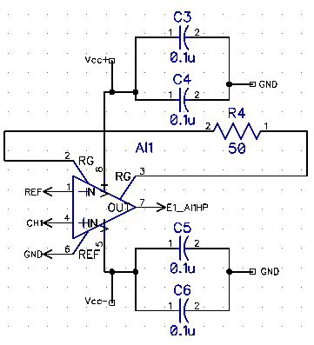The in-op configuration used in the secondary card only differs from the main circuit regarding the resistor used and the gain produced. The gain, which is given by (Gain = 1 + 19.8kΩ/RG), was increased by using a single 50Ω RG resistor, instead of two 250Ω resistors. Thus, the instrumentation amplifier is responsible for a gain of ~398. The bypass capacitors used in the main PCB were kept to regulate the supply voltage of the in-op.

*Figure 28 : DipTrace Schematic for secondary card and connection diagram of the in-op AD8422*

### Circuit amplification

Similarly to the main PCB, this circuit contains a final amplification stage located after the filters. It provides a gain with its non-inverter op-amp configuration. For this configuration, the gain is once more proportional to the ratio of the chosen resistors (Gain = 1 + Rf/Ri) R15 and R16 on figure 28. To increase the gain compared to the main PCB, PolyCortex chose to use R15=400kΩ and R16=3.4kΩ, therefore providing a gain of ~119.

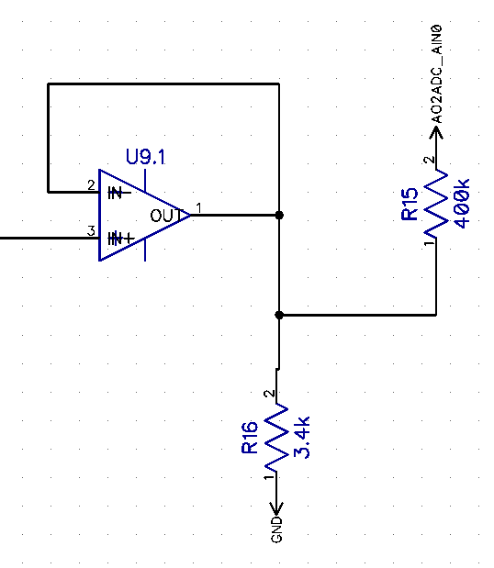

*Figure 30 : Diptrace schematic of non-inverter final amplification stage of secondary PCB*

The total gain of the circuit is therefore ~47 362.

## Simulation

Using the LTspice software, the filters were individually simulated using the same method as the main PCB and a Bode plot was produced to verify the cutoff frequencies.

### High Pass Filter

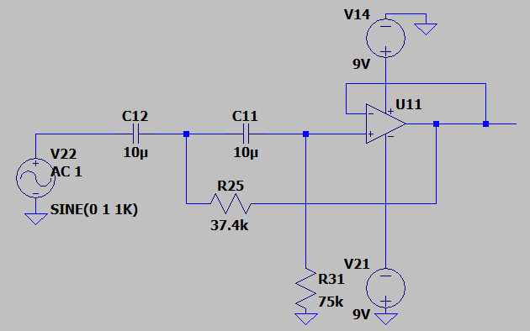

*Figure 31 : LTspice schematic of high pass filter for secondary PCB*

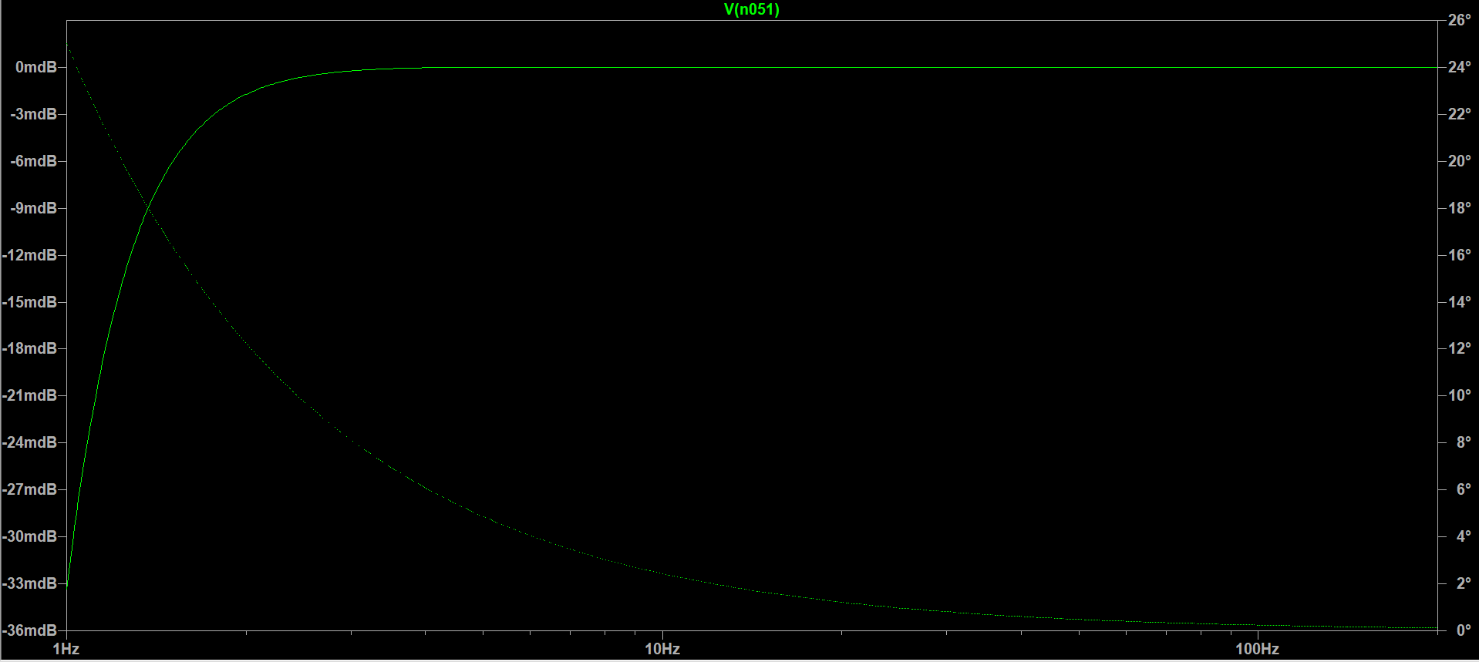

*Figure 32 : Bode plot of high pass filter with cutoff frequency of 0.3Hz for secondary PCB*

### Low Pass Filter

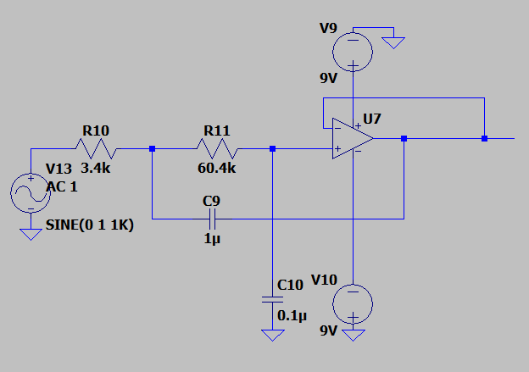

*Figure 33 : LTspice schematic of low pass filter for secondary PCB*

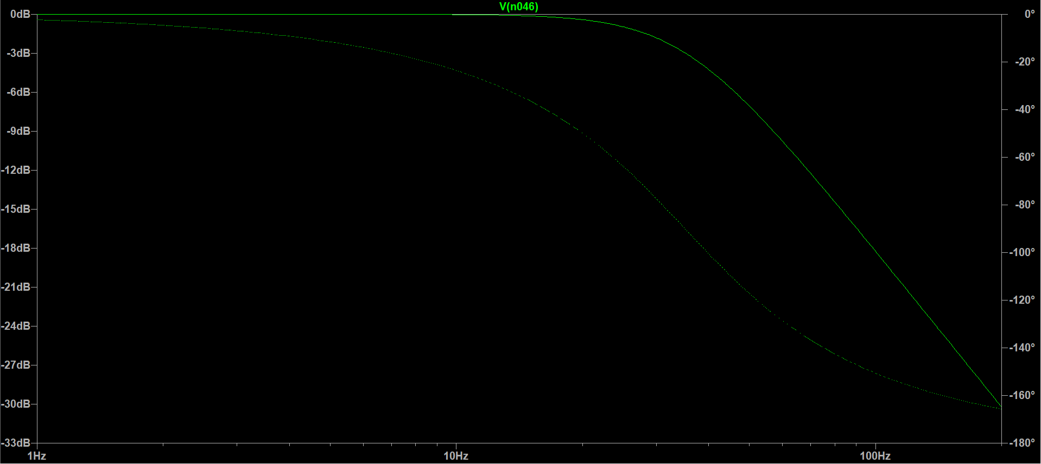

*Figure 34 : Bode plot of low pass filter with cutoff frequency of 35Hz for secondary PCB*

### Notch

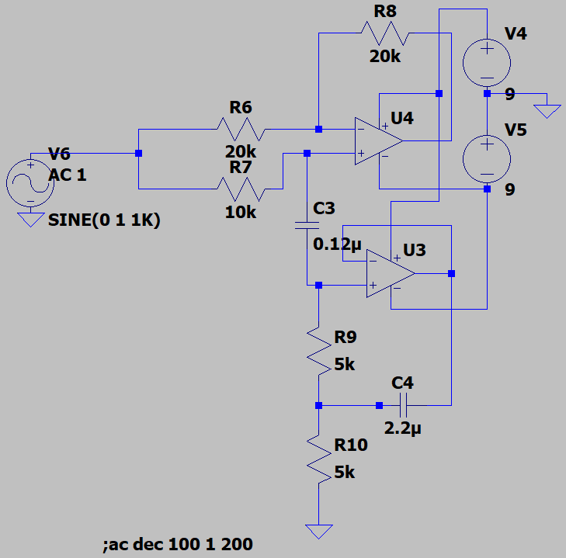

*Figure 35 : LTspice schematic of notch filter for secondary PCB*

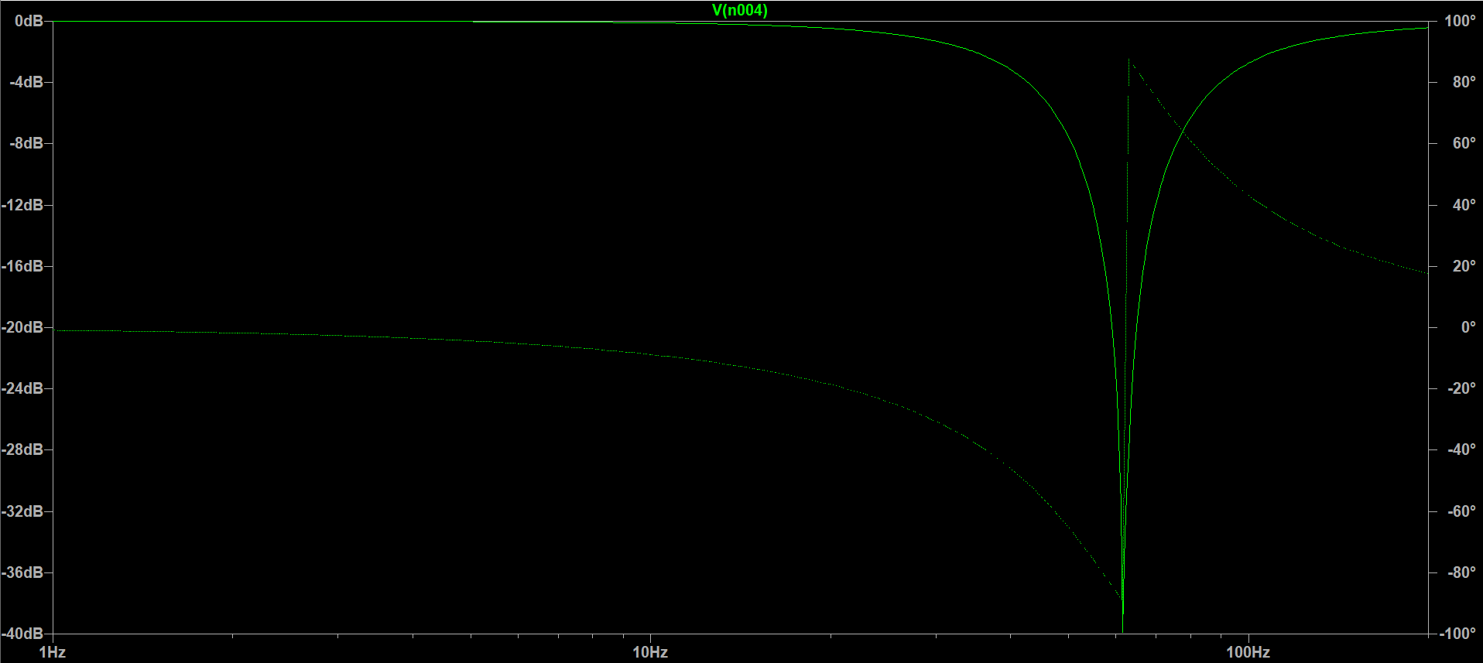

*Figure 36 : Bode plot of notch filter for secondary PCB*

### Complete channel

The circuit for a complete EEG acquisition channel was simulated with an input sinusoidal source with an amplitude of 100µV peak-to-peak. The output signal is roughly 4.6V peak-to-peak, confirming the over gain of ~46 000, which is coherent with the theorical gain of 47 362. The different between the theory and the simulation lies in the tolerance of the resistors. A slight offset is visible on the output signal, as it is not completely centered around 0V like it was originally, which is most likely due to the notch filter used. However, this offset will not affect the visualisation of the signals, as the peak-to-peak amplitude is the feature of interest.

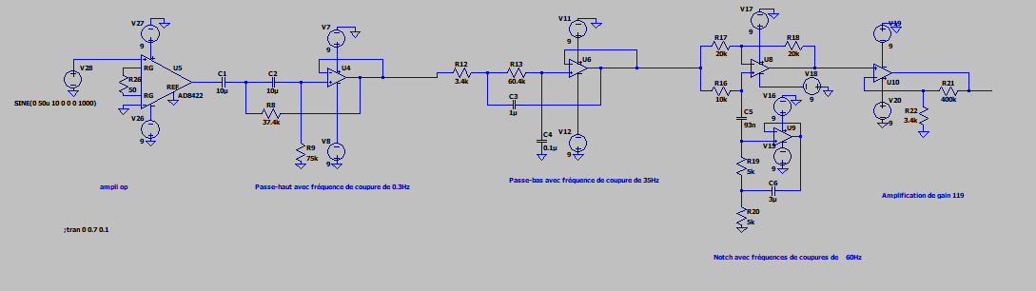

*Figure 37 : LTspice schematic of complete channel circuit for secondary PCB*

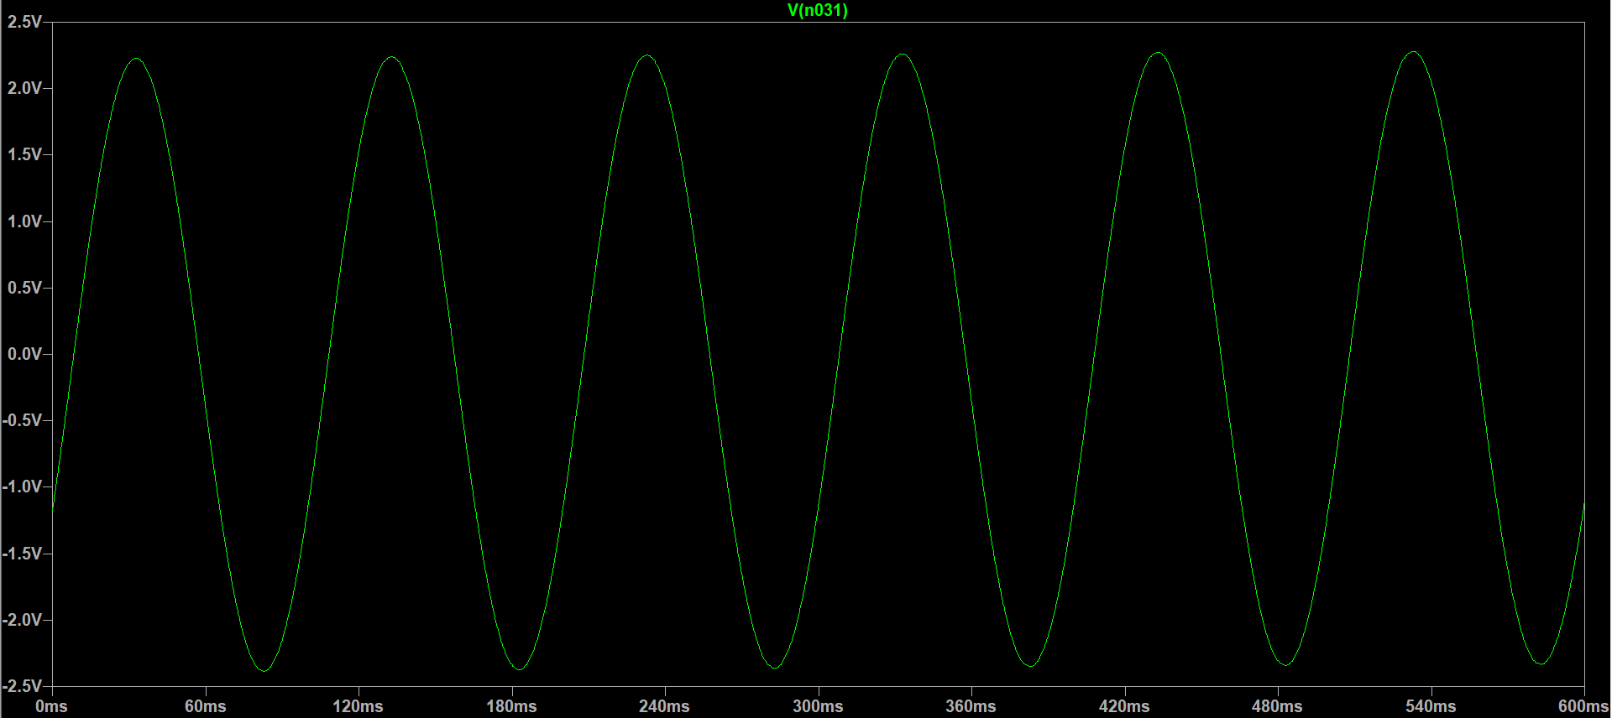

*Figure 38 : Output signal of complete circuit of 1 channel for secondary PCB*

## Other components

### ADC

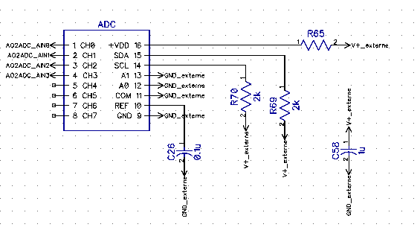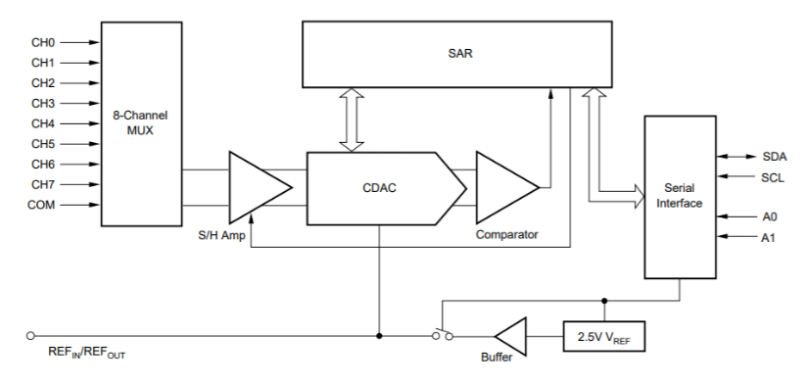PolyCortex chose to resort to an ADC model that has been tested by the team with the printing of a PCB containing only the ADC and its corresponding circuit. Thus, instead of using the Delta-Sigma ADS112C04 of the main PCB, the secondary PCB uses Texas Instruments’ ADS7828. This ADC is slightly less performant, as it uses a sampling method over 12 bits instead of the Delta-Sigma converting process over 24 bits of the ADS112C04. The ADS7828 has a built in asynchronous clock, an 8-channel multiplexer (MUX) and a sample-and-hold amplifier. It supports the I2C interface and can be set to standard, fast and high-speed modes (2, 8 & 50 kHz). In order to communicate with the interface PolyCortex has created to visualise the EEG signal, the ADC’s output is connected to an Arduino microcontroller. The Arduino also supplies the ADC with 3.3V, as the ADS7828 has an input range of 2.3V to 5V.

*Figure 39 : DipTrace schematic of the TI ADS7828 ADC and functional diagram*

#### ADC – Arduino I2C communication

An Arduino Uno board was used by our team to control the MUX of our ADC. The user-friendly I2C protocol was privileged and could provide sufficient communication speeds for a 2 kHz sampling rate (enough for EEG acquisition). Hence, a looped sequence was programmed on the Arduino to switch the MUX and read the incoming (8-bit) data, that was transformed in a 12-bit integer. It was then sent directly through the serial port to our Python interface for real-time display. Simplicity was our main goal in this part of the pipeline, as we wanted data to get from the acquisition board to the computer as fast as possible.

Next, you’ll find a copy of the C++ code we uploaded on the Arduino board for data transfer. It’s based on an open-source code from the *ControlEverythingCommunity*, accessible via their GitHub repository:

<https://github.com/ControlEverythingCommunity/ADS7828>

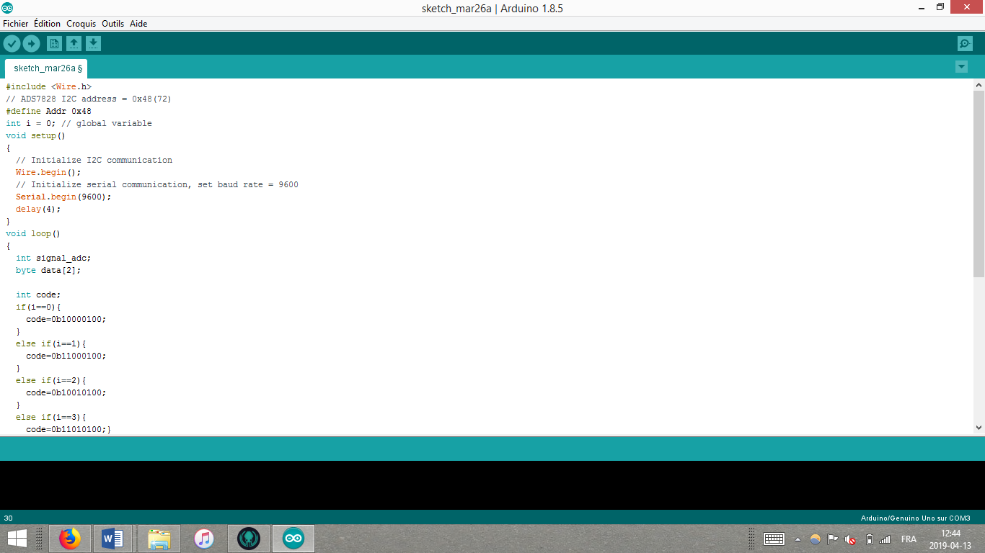

(Continued)

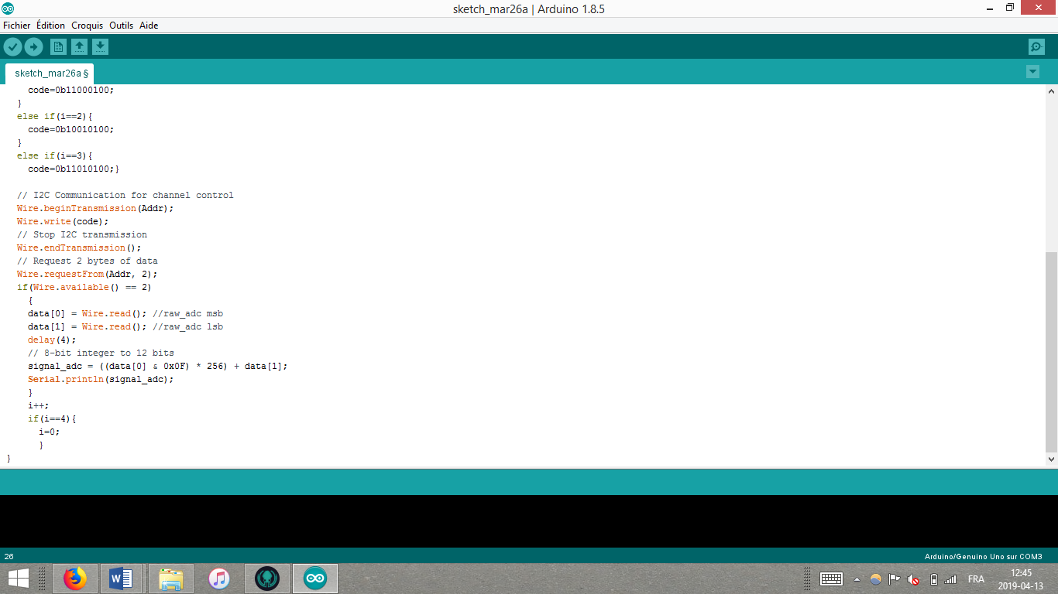

### Protection

To prevent the subject from being electrocuted any leakage electricity, the secondary card also uses Texas Instruments’ TPD4E1B06DCKR 4-channel bi-directional Transient Voltage Suppressor (TVS) diode array. It has a low leakage current (0.5nA) which insure the precision of analog measurements. Furthermore, it offers protection for currents exceeding 3.0A (8/20µS).

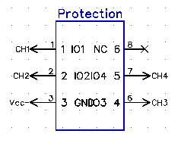

*Figure 40 : DipTrace schematic of protection circuit TPD4E1B06DCKR and functional diagram*

## Schematic, Layout and Routing

The PCB for this circuit was routed in Diptrace the same was as the main PCB. However, PolyCortex noticed the components on the main PCB were very close to each other, making it very hard to weld. Thus, the components on the secondary board were placed further apart while still respecting the maximum dimensions of 15 cm by 15 cm. The PCB itself, do to its simpler nature, was laid out and printed on only two layers, as the main PCB has four. The top layer is where the components lie, and is related to the bottom layer through static vias. Both top and bottom layers are coved by an extra coating of copper to provide the circuit’s ground, isolate the components and reduce interference between the channels. The input and output pin locations were placed as much as possible on the edges of the board to facilitate access while reducing route lengths.

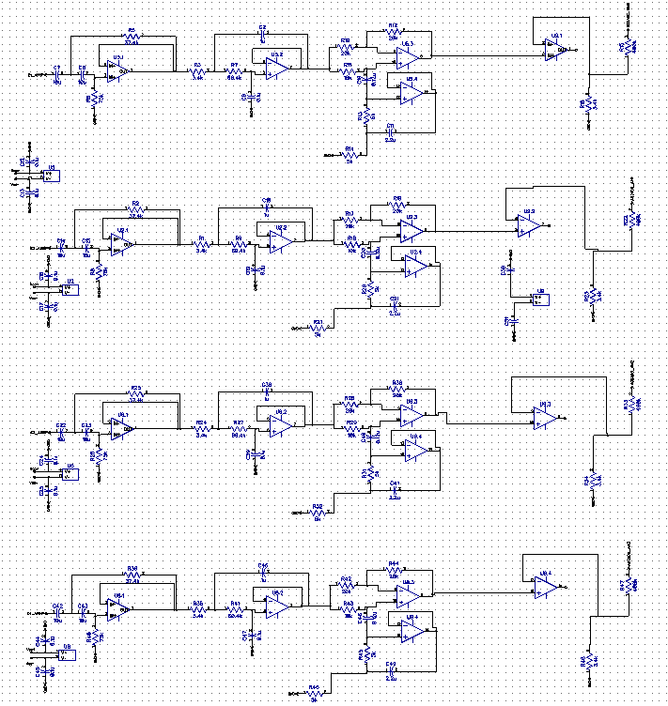

*Figure 41 : Diptrace schematic of complete 4 channels*

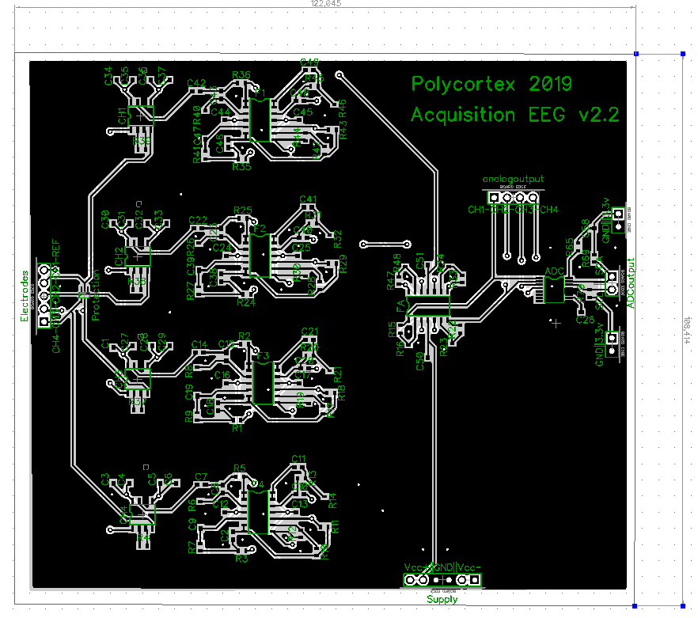

*Figure 42 : Diptrace layout and routing for secondary PCB*

The PCB was printed with PCBway, reducing the cost, and unfortunately the quality, compared to printing with Labo Circuit. PolyCortex also ordered the stencil used to weld the components onto the PCB with a soldering reflow oven.

## Testing

## Board Cost

A list of the 138 components of the circuit is annexed to this document. The total cost of the component, which were ordered on Digi-Key Electronics, is 102,87 CAN$. Five copies of the PCB was printed by PCBways for a fix cost of 141 CAN$. The board cost can therefore be evaluated to 282,16 CAN$. The total cost of the board with the component is 243,87 CAN$. The secondary board is much cheaper than the main one due to the simplicity of it’s circuit and the lesser quality of the printed PCB.

# Annexes

## Table 1 : List of components of the main PCB

|  |  |  |  |  |  |
| --- | --- | --- | --- | --- | --- |
| **Component** | **Value** | **Pattern** | **Quantity** | **$/u** | **Total $** |
| ADC | - | ADS122C04 | 1 | 9,93 | 9,93 |
| Capacitor | 0.1u | CAP_0603 | 43 | 0,0558 | 2,3994 |
| Capacitor | 1u | CAP_0603 | 6 | 0,15 | 0,9 |
| Capacitor | 10u | CAP_0603 | 9 | 0,21 | 1,89 |
| Capacitor | 0.12u | CAP_0603 | 4 | 0,33 | 1,32 |
| Capacitor | 2.2u | CAP_0603 | 4 | 0,154 | 0,616 |
| Capacitor | 0.022u | CAP_0603 | 2 | 0,073 | 0,146 |
| Capacitor | 100u | CAP_1210 | 1 | 0,949 | 0,949 |
| Capacitor | 4.7u | CAP_0603 | 6 | 0,15 | 0,9 |
| Capacitor | 0.47u | CAP_0603 | 1 | 0,12 | 0,12 |
| Capacitor | 5pF | CAP_0603 | 1 | 0,061 | 0,061 |
| Common mode choke | - | CM4732V301R-10 | 1 | 4,43 | 4,43 |
| CON | - | CON6M | 14 | 0,068 | 0,94 |
| DCDC Converter | - | LMZ12002 | 1 | 7,69 | 7,69 |
| DCDC Converter | - | LT3483IS6 | 1 | 6,81 | 6,81 |
| Diode | - | PMEG3002AEB | 1 | 0,49 | 0,49 |
| Inductance | 4.7uH | LQH2MCN100K02L | 1 | 0,38 | 0,38 |
| Inductance | - | Ferrite-200 | 2 | 0,079 | 0,158 |
| Instrumentation amp | - | AD8422 | 4 | 8,81 | 35,24 |
| Operational amp | - | LM324 | 10 | 0,295 | 2,95 |
| Potentiometer | 500-1M | 201XR | 1 | 0,79 | 0,79 |
| Protection | - | TPD4E1B0 | 2 | 0,736 | 1,472 |
| Resistor | 26.7k | RES_0603 | 8 | 0,53 | 4,24 |
| Resistor | 3.4k | RES_0603 | 16 | 0,53 | 8,48 |
| Resistor | 250 | RES_0603 | 8 | 2,15 | 17,2 |
| Resistor | 37.4k | RES_0603 | 4 | 0,15 | 0,6 |
| Resistor | 75k | RES_0603 | 4 | 1 | 4 |
| Resistor | 60.4k | RES_0603 | 4 | 0,53 | 2,12 |
| Resistor | 20k | RES_0603 | 8 | 0,1172 | 0,9376 |
| Resistor | 10k | RES_0603 | 9 | 0,15 | 1,35 |
| Resistor | 5k | RES_0603 | 8 | 3,07 | 24,56 |
| Resistor | 40k | RES_0603 | 4 | 0,839 | 3,356 |
| Resistor | 1k | RES_0603 | 4 | 0,15 | 0,6 |
| Resistor | 32.4k | RES_0603 | 2 | 0,1172 | 0,2344 |
| Resistor | 2.5k | RES_0603 | 1 | 1,217 | 1,217 |
| Resistor | 11.8k | RES_0603 | 1 | 0,3 | 0,3 |
| Resistor | 2.1k | RES_0603 | 1 | 0,39 | 0,39 |
| Resistor | 250k | RES_0603 | 1 | 0,8761 | 0,8761 |
| Resistor | 10 | RES_0603 | 1 | 0,54 | 0,54 |
| RF Filter | - | EMI T filter | 6 | 0,483 | 2,898 |
| Supply battery | 9V | - | 1 | 2,572 | 2,572 |
| **TOTAL** | **-** | **-** | **207** | **-** | **157,06** |

## Table 2 : List of components for secondary PCB

|  |  |  |  |  |  |
| --- | --- | --- | --- | --- | --- |
| **Componant** | **Value or Model** | **Pattern** | **Quantity** | **Price $/u** | **Total** |
| ADC | ADS7828 | ADS7828 | 1 | 11,66 | 11,66 |
| Capacitor | 0.12u | CAP_0603 | 4 | 0,33 | 1,32 |
| Capacitor | 0.1u | CAP_0603 | 31 | 0,0558 | 1,7298 |
| Capacitor | 10u | CAP_0603 | 8 | 0,21 | 1,68 |
| Capacitor | 1u | CAP_0603 | 5 | 0,15 | 0,75 |
| Capacitor | 2.2u | CAP_0603 | 4 | 0,154 | 0,616 |
| CON | Male | - | 22 | 0,0671429 | 1,4771438 |
| Instrumentation amp | AD8422 | AD8422 | 4 | 8,81 | 35,24 |
| Operational amp | LM324 | LM324 | 5 | 0,295 | 1,475 |
| Protection | TPD4E1B06DCKR | TPD4E1B0 | 1 | 0,739 | 0,739 |
| Resistor | 10k | RES_0603 | 4 | 0,15 | 0,6 |
| Resistor | 20k | RES_0603 | 8 | 0,1172 | 0,9376 |
| Resistor | 2k | RES_0603 | 2 | 0,53 | 1,06 |
| Resistor | 3.4k | RES_0603 | 8 | 0,53 | 4,24 |
| Resistor | 37.4k | RES_0603 | 4 | 0,15 | 0,6 |
| Resistor | 400k | RES_0603 | 4 | 0,511 | 2,044 |
| Resistor | 5 | RES_0603 | 1 | 0,24 | 0,24 |
| Resistor | 50 | RES_0603 | 4 | 0,16 | 0,64 |
| Resistor | 5k | RES_0603 | 8 | 3,07 | 24,56 |
| Resistor | 60.4k | RES_0603 | 4 | 0,53 | 2,12 |
| Resistor | 75k | RES_0603 | 4 | 1 | 4 |
| Supply | 9V | - | 2 | 2,572 | 5,144 |
| **TOTAL** | **-** | **-** | **138** | **-** | **102,87** |

# Reference

1.